Week 6
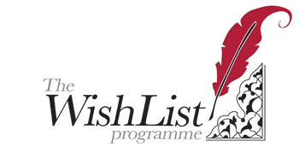

This week’s phrase to remember is;
Tao means The Way. The Tao is the way of heaven and earth. Nothing in life is static-all is a process of change. From the incomplete comes the complete.
This week focuses on your astrology and how it can be used to improve the quality of your decision making. At its basis it recognizes that our lives are always in a state of change.

Chinese Astrology is called Bazi or Four Pillars Feng Shui. It involves far more than just describing the animal of the year in which you were born. It includes four main animals, along with a new one every 10 years and another one each year. For example this is the Year of The Goat.
The four main animals each sit in a pillar and have a stem and a branch. The stem is an element either in a yin polarity or a yang polarity. This sits on top of a branch, which is also an element, but it is expressed as an animal. So put them together for example you might have a Yin Metal Dog, where Yin Metal is the stem on top and the Dog is the branch sitting below it. We have a pillar for the Year of birth, one for the Month, one for the Day and one for the Hour.
Here’s an example of a chart.
-Wood | -Earth | + Fire | + Metal
Horse | Ox | Dog | Tiger

The most significant thing to know is that your chart is like a template of your life, but it is not your destiny set in stone. Instead, you have many chances to change it. Once you know how your chart works, ie what is favourable for you and what is unfavourable, then you can begin to balance your life by making decisions that put you in the FLOW. By working with your favourable elements, your life is easier. If you work against them you make your life harder than it needs to be.
So here is what you will discover when we look at your chart.
- You will discover what your favourable elements are from the 5, Fire, Earth, Metal, Water and Wood.
- You will learn HOW you can work with them to bring in more balance.
- You will understand why your recent months have unfolded as they have, in relation to your chart and to this year in question.
- It will help you understand the main influences of this year on you and how you can work with it to gain what you want.
This week also allows me to calculate the best days coming up in the near future, that you can use to take action on your dreams.
We will also discuss what actions you can take on these auspicous days.

